William E. Grady Career & Technical High School
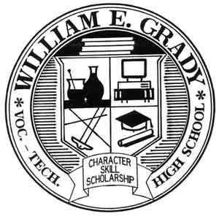
25 Brighton 4th Road, Brooklyn, NY 11235 Ph: 718-332-5000 / F: 718-332-2544

Tarah Montalbano, Principal
Tmontalbano@schools.nyc.gov

December 20, 2021
Dear Grady Families,
If your child is exposed to Covid-19 at school, you will receive a call and/or letter notifying you that your child may need to quarantine. If your child is unvaccinated and exposed to Covid-19, he/she will have to quarantine for ten days, with the opportunity to return on the eighth day by testing negative on the sixth or seventh day of the quarantine period. If your child is vaccinated, he/she does not need to quarantine and can return to school even if you receive a notice of close contact.
During the quarantine period, your child will attend school remotely, as follows:
Please make note of the following remote instruction protocol for students who have been quarantined due to close contact with Covid-19. Only students who received notification that they were exposed are to be attending classes remotely. All other students, including those who were exposed and fully vaccinated, are to be present in person in school.
- Students must log into the Google classrooms each day of their quarantine period. Student attendance will be based on completion of remote work. Students should also confirm attendance by posting “Here” on the Google stream.
- Teachers will post asynchronous work daily that is reflective of the same work and topics they are covering in class.
- In the Google classroom, teachers will indicate the time of day (equal to two hours per week) that they are available for office hours. During office hours, teachers will be available via live meet to assist students and reach out to students or parents who have sent them questions/concerns. However, the bulk of the time will be spent helping students.
- Students should log into each teacher's Google classroom to complete the asynchronous assignments, and make note of office hours to attend as needed for support.
- If your child's teacher is also being quarantined due to close contact, that teacher will teach his/her quarantined students via live meet using Google classroom, in the same manner as when we were fully remote. If this is the case for any class, the teacher will indicate that in his/her Google classroom stream.
Once again, this ONLY applies to students who have been told to quarantine due to close contact with a positive Covid case in the school. All other students, including vaccinated students who were close contacts, should be attending school in person.
If your child has been directed to quarantine, and does not have a device for remote learning, please let us know ASAP.

For immediate help, we can be reached as follows:
Parent Coordinator Stacey Matone: smatone@schools.nyc.gov 718-332-5000, ext. 1350
AP Leitzsey: nleitzsey@schools.nyc.gov 718-332-5000, ext. 1420
Principal Montalbano: tmontalbano@schools.nyc.gov 718-332-5000, ext. 1470

Thank you for your support during this unprecedented time. Wishing all of our families the best of health.

Sincerely,
Tarah Montalbano
Principal Montalbano

